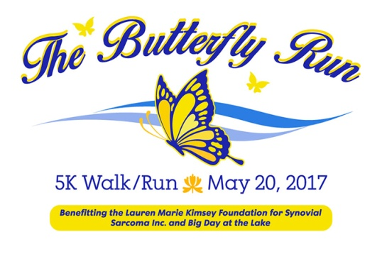
2017 5K Sponsorship Agreement

Name of Organization: __________________________________________________________________
Address: __________________________________________City/Zip Code: _______________________
Website: _____________________________________________________________________________
Owner/Contact: _______________________________________________________________________
Email/Phone Number: __________________________________________________________________
__ Yes, we would like to become a 2017 Butterfly Run event sponsor
Sponsorship Level ______________________________________________________________________
__ Yes, we would like to become an in-kind sponsor. We would like to offer ____________ as an in-kind sponsorship.
__ No, but we would like to make a tax deductible donation to
__ The Lauren Marie Kimsey Foundation for Synovial Sarcoma, Inc.
In the amount of $ ____________ (81-4645722)
__ Big Day at the Lake
In the amount of $ ____________ (56-2264009)

_ No, but for $50 we would like to include our promotional items in the race goody bags

We understand and agree that in order to become a Butterfly Run event sponsor and to be part of promotional opportunities, our sponsorship funds, digital company logo, and all promotional materials must be provided by May 17th to Race Director Laura Engel (see contact information below). Logo for t shirts must be provided by May 1, 2017?

_______________________________________________________ __________________________
Sponsor Signature Date

PLEASE RETURN THIS FORM TO:
Laura Engel
AQUESTA BANK, 19510 Jetton Road, Cornelius, NC 28031 704-439-1409/email: lengel@aquestabank.com

