Inaugural Butterfly Run Sponsorship Opportunities
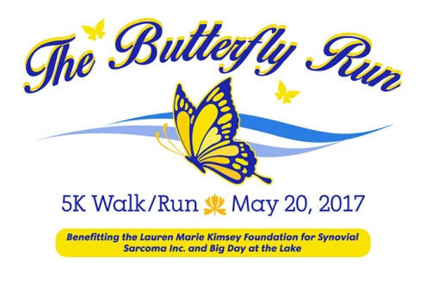
_____________________________________________________________________________________
Golden Butterfly Presenting Sponsor
$2,500
_____________________________________________________________________________________
- Exclusive Sponsorship/Listed as Presenting Sponsor
- Press Release with your company name. Press release and logo posted on Aquesta Bank website
- Quote in news releases
- Speaking Opportunity at Race
- Butterfly Run provided banner with sponsor name/logo at race
- Acknowledgment of sponsorship in Aquesta Bank branches
- Logo on all race materials, social media, website and t-shirts
- Name mentioned at podium throughout the day
- Listed in print ads
- Vendor space at event
- Company marketing materials/goods included in race packets
- 6 complimentary race entries

_____________________________________________________________________________________
Butterfly Kisses Sponsor
$1,000
_____________________________________________________________________________________
- Logo on all race materials, social media, website and t-shirts
- Name mentioned at podium throughout the day
- Acknowledgment of sponsorship in Aquesta Bank branches
- Self provided banner at race
- Listed in print ads
- Vendor space at event
- Company marketing materials/goods included in race packets
- 4 complimentary race entries

Inaugural Butterfly Run Sponsorship Opportunities

_____________________________________________________________________________________
Butterfly Wings Sponsorship
$750
_____________________________________________________________________________________
- Logo on all race materials, social media, website and t-shirts
- Name mentioned at podium throughout the day
- Self provided banner at race
- Vendor space at event
- Company marketing materials/goods included in race packets
- 2 complimentary race entries

_____________________________________________________________________________________
Fluttering Butterfly Sponsorship
$500
_____________________________________________________________________________________
- Vendor space at event
- Self provided banner at race
- Company marketing materials/goods included in race packets
- 2 mentions on social media
- Company name on t shirts
- 1 complimentary race entry

Inaugural Butterfly Run Sponsorship Opportunities

_____________________________________________________________________________________Floating Butterfly Sponsor
$250
_____________________________________________________________________________________
- Vendor space at event
- Self provided banner at race
- 1 mention on social media
- Company marketing materials/goods included in race packets
- 1 complimentary race entry

_____________________________________________________________________________________
Caterpillar Sponsor
$100
_____________________________________________________________________________________

- Vendor space at event
- 1 mention of social media
- Company marketing materials/goods included in race packets

